Chapter 11, Problem 35.

One cycle of a periodic voltage waveform is depicted in Fig.11.66. Find the effective value of the voltage. Note that the cycle starts at t = 0s and ends at t = 6s.

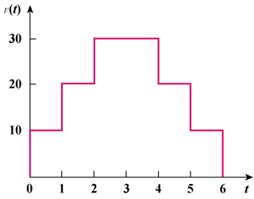

Figure 11.66
For Prob. 10.35.

